# DATABASE EXAM

# Konare Trade Bank(KTB)

After months of hard work, you finally made it! You have started to work for Konare Trade Bank(KTB) as a database developer. It is so unique that you have the feeling that there is no bank like this. In order to get the complete amount of your precious salary at the end of the month you have to complete **4 simple sections**. But that is not all – there is a sweet bonus if you are good enough to finish section 5. Here are your tasks:

# Section 1. DDL

# **25 pts**

**For this section put your queries in judge and use SQL Server run skeleton, run queries and check DB.**

You have been given the E/R Diagram of the bank:

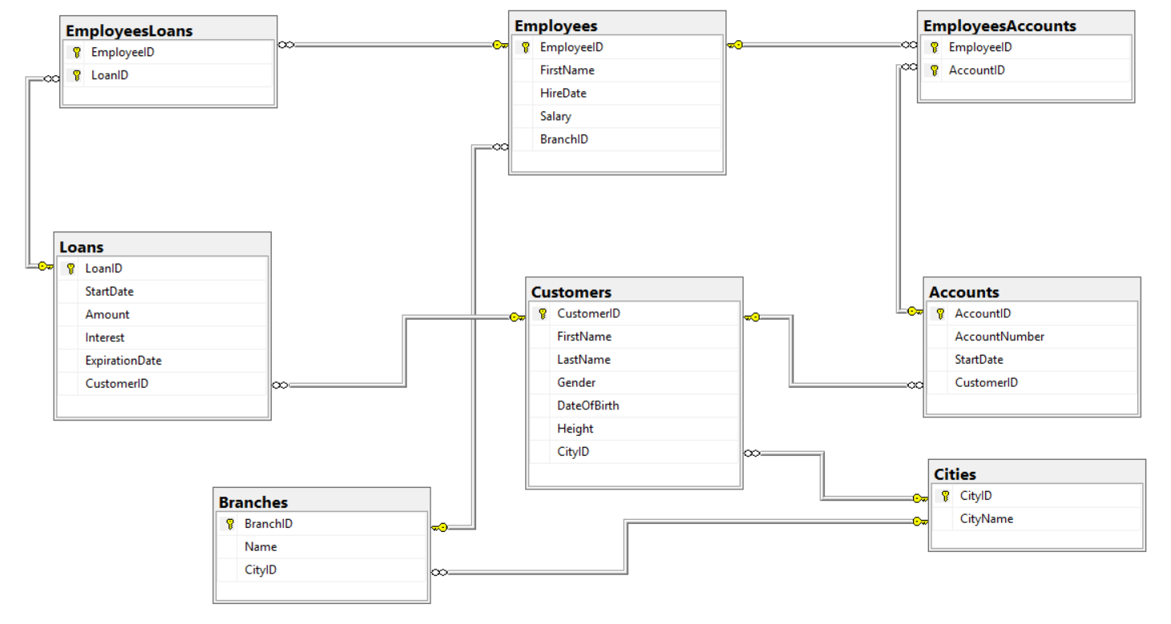

In KTB we have Customers who have 0, 1 or many Loans and Accounts. Moreover, we have employees. Employees are responsible for the maintenance of the loans and the accounts. Many employees have responsibilities over many loans and accounts. Furthermore, Employees are located in different branches. Branches are located in cities just like our customers are.

Since the business is blooming you have to extend the following diagram with 6 tables and to modify one of the existing tables. Make sure you have done appropriately the following specifics:

* Primary Keys
* Foreign Keys
* Data Types
* 6 Tables
* Create the constraint within the CREATE TABLE Statement
* 1 Table Modification

Here are the tables that you need to create:

The bank is about to start offering deposits. That is why we need few tables. Every customer has 1, 0 or many deposits. Every deposit has 0 or 1 one deposit types. Many employees will be responsible for the maintenance of the deposits. That’s why we would need a mapping table. Customers now have credit history. Every customer can have many different credit marks. Our customers have started to pay their loans. Therefore, we need a table Payments. Every loan can have 0, 1 or many payments. KTB has a new web site and we would need another table for users. Every customer has exactly one user. Here are some details about the tables we need.

**Deposits**

|  |  |  |
| --- | --- | --- |
| **Column Name** | **Data Type** | **Constraints** |
| DepositID | Integer from –2,147,483,648 to 2,147,483,647 | Unique table identificator, Identity |
| Amount | Decimal with length of 10, 2 digits after the decimal point |  |
| StartDate | Date without time |  |
| EndDate | Date without time |  |
| DepositTypeID | Integer from –2,147,483,648 to 2,147,483,647 | Relationship with DepositTypes |
| CustomerID | Integer from–2,147,483,648 to 2,147,483,647 | Relationship with table Customers |

**DepositTypes**

|  |  |  |
| --- | --- | --- |
| **Column Name** | **Data Type** | **Constraints** |
| DepositTypeID | Integer from –2,147,483,648 to 2,147,483,647 | Unique table identificator |
| Name | String up to 20 symbols |  |

**EmployeesDeposits**

|  |  |  |
| --- | --- | --- |
| **Column Name** | **Data Type** | **Constraints** |
| EmployeeID | Integer from –2,147,483,648 to 2,147,483,647 | Unique table identificator; Relationship with table Employees |
| DepositID | Integer from –2,147,483,648 to 2,147,483,647 | Unique table identificator; Relationship with table Deposits |

**CreditHistory**

|  |  |  |
| --- | --- | --- |
| **Column Name** | **Data Type** | **Constraints** |
| CreditHistoryID | Integer from –2,147,483,648 to 2,147,483,647 | Unique table identificator |
| Mark | Character with 1 symbol |  |
| StartDate | Date without time |  |
| EndDate | Date without time |  |
| CustomerID | Integer from –2,147,483,648 to 2,147,483,647 | Relationship with table Customers |

**Payments**

|  |  |  |
| --- | --- | --- |
| **Column Name** | **Data Type** | **Constraints** |
| PayementID | Integer from –2,147,483,648 to 2,147,483,647 | Unique table identificator |
| Date | Date without time |  |
| Amount | Decimal with length of 10, 2 digits after the decimal point |  |
| LoanID | Integer from –2,147,483,648 to 2,147,483,647 | Relationship with table Loans |

**Users**

|  |  |  |
| --- | --- | --- |
| **Column Name** | **Data Type** | **Constraints** |
| UserID | Integer from –2,147,483,648 to 2,147,483,647 | Unique table identificator |
| UserName | String up to 20 symbols |  |
| Password | String up to 20 symbols |  |
| CustomerID | Integer from –2,147,483,648 to 2,147,483,647 | Relationship with table Customers, Unique Values |

Modify table **Employees.** Add column Manager ID

**Employees**

|  |  |  |
| --- | --- | --- |
| **Column Name** | **Data Type** | **Constraints** |
| …. |  |  |
| ManagerID | Integer from –2,147,483,648 to 2,147,483,647 | Relationship with table Employees |

**Put all of your queries that solve Section 1. In judge use SQL Server run skeleton, run queries and check DB.**

# Section 2. DML

# **20 pts**

**For this section put your queries in judge and use SQL Server run skeleton, run queries and check DB.**

In this section you have to do couple of data manipulations:

## Insert data into the following tables

**EmployeesDeposits**

|  |  |
| --- | --- |
| **EmployeeID** | **DepositID** |
| 15 | 4 |
| 20 | 15 |
| 8 | 7 |
| 4 | 8 |
| 3 | 13 |
| 3 | 8 |
| 4 | 10 |
| 10 | 1 |
| 13 | 4 |
| 14 | 9 |

**DepositTypes**

|  |  |
| --- | --- |
| **DepositTypeID** | **Name** |
| 1 | Time Deposit |
| 2 | Call Deposit |
| 3 | Free Deposit |

**Deposits**

Add all customers with ID lower than 20 to table Deposits.

* The id should be auto generated from table Deposits
* The deposit amount is based on the following logic
  + If you are born after 01-01-1980 then it is 1000 BGN else, it is 1500 BGN
  + If you are Male add 100 BGN else add 200 BGN
* The start date should be the current date
* The end should be empty
* The deposit type id should 1 if the customer id is odd and 2 if the customer id is even. If the customer id is larger than 15 then the deposit type should be 3.
* The acustomer id should come from table Customers

## Update Employees

Update table Employees. The manager id should have the following values:

* If EmployeeID is in the range [2;10] then the value is 1
* If EmployeeID is in the range [12;20] then the value is 11
* If EmployeeID is in the range [22;30] then the value is 21
* If EmployeeID is in 11 or 21 then 1

## Delete Records

Delete all records from EmployeeDeposits if the DepositID is 9 or the EmployeeID is 3;

# Section 3. Querying

# **40 pts**

**For this section put your queries in judge and use SQL Server prepare DB and run queries.**

## Employees’ Salary

Write a query that returns

* [EmployeeID]
* [HireDate]
* [Salary]
* [BranchID]

From table Employees. Filter employees which salaries are higher than 2000 and their hire date is after 15/06/2009.

### Example

|  |  |  |  |
| --- | --- | --- | --- |
| **EmployeeID** | **HireDate** | **Salary** | **BranchID** |
| 5 | 2009-12-23 | 2295.88 | 12 |

## Customer Age

Write a query that returns

* [FirstName]
* [DateOfBirth]
* [Age]

of all customers who are between 40 and 50 years old. The range is inclusive. Consider that today is 01-10-2016.

### Example

|  |  |  |
| --- | --- | --- |
| **FirstName** | **DateOfBirth** | **Age** |
| Bruce | 1970-09-17 | 46 |

## Customer City

Write a query that returns

* [CustomerID]
* [FirstName]
* [LastName]
* [Gender]
* [CityName]

for all customers whose last name starts with ‘Bu’ or first name ends with ‘a’. Moreover, for those customers the length of the city name should at least 8 letters. Sort by CustomerID in ascending order.

### Example

|  |  |  |  |  |
| --- | --- | --- | --- | --- |
| **CustomerID** | **FirstName** | **LastName** | **Gender** | **CityName** |
| 13 | Christina | Little | F | Budapest |

## Employee Accounts

Write a query that returns top 5

* [EmployeeID]
* [FirstName]
* [AccountNumber]

of all employees who are responsible for maintaining accounts which has started after the year of 2012. Sort the results by the first name of the employees in descending order.

### Example

|  |  |  |
| --- | --- | --- |
| **EmployeeID** | **FirstName** | **AccountNumber** |
| 26 | William | 501012430845 |

## Employee Cities

Write a query that returns

* [CityName]
* [Name] (of the branch)
* [EmployeesCount]

The count of all employees grouped by city name and branch name. Exclude cities with id 4 and 5. Don’t show groups with less than 3 employees. Select

### Example

|  |  |  |
| --- | --- | --- |
| **CityName** | **Name** | **EmployeesCount** |
| Budapest | Angela | 3 |

## Loan Statistics

Write a query that returns

* The total amount of loans
* Max interest of loans
* Min salary of employees

Of all employees that are responsible for maintaining the loans.

### Example

|  |  |  |
| --- | --- | --- |
| **TotalLoanAmount** | **MaxInterest** | **MinEmployeeSalary** |
| 1469561.30 | 0.91 | 1639.97 |

## Unite People

Write a query that returns top 3 employees’ first names and the city name of their branch followed by top 3 customer’s first names and the name of the city they live in.

### Example

|  |  |
| --- | --- |
| **FirstName** | **CityName** |
| Deborah | Orlu |

## Customers without Accounts

Write a query that returns

* [CustomerID]
* [Heigtht]

of all customers who doesn’t have accounts. Filter only those who are tall between 1.74 and 2.04.

### Example

|  |  |
| --- | --- |
| **CustomerID** | **Height** |
| 11 | 1.78 |

## Customers without Accounts

Write a query that returns top 5 rows

* [CustomerID]
* [Amount]

of all customers who have loans higher than the average loan amount of the male customers. Sort the data by customer last name in ascending order.

### Example

|  |  |
| --- | --- |
| **CustomerID** | **Amount** |
| 4 | 88067.24 |

## Oldest Account

Write a query that returns

* [CustomerID]
* [FirstName]
* [StartDate]

for the customer with the oldest account.

### Example

|  |  |  |
| --- | --- | --- |
| **CustomerID** | **FirstName** | **StartDate** |
| 27 | Howard | 2010-10-13 |

# Section 4. Programmability

# **20 pts**

**For this section put your queries in judge and use SQL Server run skeleton, run queries and check DB.**

## String Joiner Function

Write a function with name **udf_ConcatString** that reverses two strings, joins them and returns the concatenation. The function should have two input parameters of type VARCHAR.

## Unexpired Loans Procedure

Write a procedure that returns a customer if it has unexpired loan. The following result set should be returned:

* CustomerID
* FirstName
* LoanID

The function should have one parameter for CustomerID of type integer. Name the function **usp_CustomersWithUnexpiredLoans.** If the id of the customer doesn’t have unexpired loans return an empty result set.

### Example

EXEC usp_CustomersWithUnexpiredLoans @CustomerID = 9

|  |  |  |
| --- | --- | --- |
| **CustimerID** | **FirstName** | **LoanID** |
| 9 | Bobby | 23 |

## Take Loan Procedure

Write a procedure that adds a loan to an existing customer. The procedure should have the following input parameters:

* CustomerID
* LoanAmount
* Interest
* StartDate

If the loan amount is not between 0.01 AND 100000 raise an error ‘Invalid Loan Amount.’ And rollback the transaction.

If no error is raised insert the loan into table Loans. The column LoanID has an identity property so there is no need to specify a value for it.

Name the procedure **usp_TakeLoan.**

### Example

EXEC usp_TakeLoan @CustomerID = 1, @LoanAmount = 500, @Interest = 1, @StartDate='20160915'

1. row(s) affected)

## Trigger Hire Employee

Write a trigger on table Employees. After an insert of a new employee the new employee takes the loan maintenance of the previous employee.

### Hint

Your trigger should update table EmployeesLoans

### Example

##### Before Insert

|  |  |  |  |  |
| --- | --- | --- | --- | --- |
| EmployeeID | FirstName | HireDate | Salary | BranchID |
| 30 | Diane | 2006-03-18 | 2574.01 | 6 |

|  |  |
| --- | --- |
| EmployeeID | LoanID |
| 30 | 7 |

INSERT INTO Employees VALUES (31, 'Jake', '20161212', 500, 2)

##### After Insert

|  |  |  |  |  |
| --- | --- | --- | --- | --- |
| EmployeeID | FirstName | HireDate | Salary | BranchID |
| 30 | Diane | 2006-03-18 | 2574.01 | 6 |
| 31 | Jake | 2016-12-12 | 500 | 2 |

|  |  |
| --- | --- |
| EmployeeID | LoanID |
| 31 | 7 |

# Section 5. Bonus

# **10 pts**

**For this section put your queries in judge and use SQL Server run skeleton, run queries and check DB.**

## Delete Trigger

Create a table with the same structure as table Accounts and name it **AccountLogs**. Then create a trigger that logs the deleted records from table Accounts into table AccountLogs. Post in judge only the create trigger statement.

### Example

DELETE FROM [dbo].[Accounts] WHERE CustomerID = 4

**AccountLogs**

|  |  |  |  |
| --- | --- | --- | --- |
| AccountID | AccountNumber | StartDate | CustomerID |
| 31 | 352806149112 | 2016-08-05 | 4 |